集美大学计算机工程学院实验报告

课程名称：Java程序设计 | 班级：软件1912 | 实验成绩：
指导教师：李 旺 | 姓名：施嘉宏
实验项目名称：流与文件 | 学号：201921122044 | 上机实践日期：
实验项目编号：8 | 组号： | 上机实践时间： 2 学时

一、目的
1）理解流与文件的区别与联系；
2）掌握各种流操作方法。
二、实验内容与设计思想
1．设计思路
文件管理器使用了多叉树作为文件目录树。
二进制文件查看器使用bufferinputstream读取二进制数据，然后转化为16进制数据和ASCII码
2．主要数据结构
多叉树
3．主要代码结构
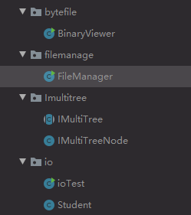
1）字节流、过滤流、字符流、对象流
public class ioTest {
public static final String file1 = "text/obj1.txt";
public static final String file2 = "text/obj2.txt";
public static final String file3 = "text/obj3.txt";
public static Student readStudent(DataInputStream dis) throws IOException {
String name = dis.readUTF();
int id = dis.readInt();
int age = dis.readInt();
double grade = dis.readDouble();
return new Student(name, id, age, grade);
}
public static void writeStudent(Student s, DataOutputStream dos) throws IOException {
dos.writeUTF(s.getName());
dos.writeInt(s.getId());
dos.writeInt(s.getAge());
dos.writeDouble(s.getGrade());
}
public static Student readStudent(ObjectInputStream ois) throws IOException, ClassNotFoundException{
return (Student) ois.readObject();
}
public static void writeStudent(Student s, ObjectOutputStream oos) throws IOException {
oos.writeObject(s);
}
public static Student readStudent(Scanner s) {
String[] para = s.nextLine().split(",");
String name = para[0];
int id = Integer.parseInt(para[1]);
int age = Integer.parseInt(para[2]);
double grade = Double.parseDouble(para[3]);
return new Student(name, id, age, grade);
}
public static void writeStudent(Student s, PrintWriter pw) {
pw.write(s.toString());
}
public static void method1() {
System.out.println("test 1");
Student stu = new Student("tom", 1, 16, 60.5);
//TWR try-with-resources
try (DataOutputStream dos = new DataOutputStream(new FileOutputStream(file1));
DataInputStream dis = new DataInputStream(new FileInputStream(file1))){
writeStudent(stu, dos);
dos.flush();
stu = readStudent(dis);
System.out.println(stu);
} catch (IOException e) {
e.printStackTrace();
}
}
public static void method2() {
System.out.println("test 2");
Student stu = new Student("tom", 1, 16, 60.5);
try (PrintWriter fop = new PrintWriter(new FileOutputStream(file2));
Scanner fis = new Scanner(new FileInputStream(file2))){
writeStudent(stu, fop);
fop.flush();
stu = readStudent(fis);
System.out.println(stu);
} catch (IOException e) {
e.printStackTrace();
}
}
public static void method3() {
System.out.println("test 3");
Student stu = new Student("tom", 1, 16, 60.5);
try (ObjectOutputStream oos = new ObjectOutputStream(new FileOutputStream(file3));
ObjectInputStream ois = new ObjectInputStream(new FileInputStream(file3))){
writeStudent(stu, oos);
oos.flush();
stu = readStudent(ois);
System.out.println(stu);
} catch (IOException | ClassNotFoundException e) {
e.printStackTrace();
}
}
public static void main(String[] args) {
method1();
method2();
method3();
}
}
2）文件管理
public class FileManager extends JFrame {
private File rootFile;
private JFileChooser fileChooser;
private JLabel pathName;
private JTextArea fileMsg;
private JButton open;
private final Map<File, Integer> dirNum;
private final Map<File, Integer> fileNum;
public FileManager() {
this.setVisible(true);
this.setDefaultCloseOperation(WindowConstants.EXIT_ON_CLOSE);
this.setLocationRelativeTo(null);
rootFile = null;
fileNum = new HashMap<>();
dirNum = new HashMap<>();
Font font = new Font("黑体", Font.PLAIN, 18);
JPanel msgPanel = new JPanel(new BorderLayout(5, 5));
JScrollPane scrollPane = new JScrollPane(msgPanel, ScrollPaneConstants.VERTICAL_SCROLLBAR_AS_NEEDED, ScrollPaneConstants.HORIZONTAL_SCROLLBAR_AS_NEEDED);
fileMsg = new JTextArea();
fileChooser = new JFileChooser(new File("."));
fileChooser.setFileSelectionMode(JFileChooser.DIRECTORIES_ONLY);
pathName = new JLabel(".");
open = new JButton("选择路径");
JScrollBar bar = scrollPane.getVerticalScrollBar();
bar.setUnitIncrement(45);
pathName.setFont(font);
fileMsg.setFont(new Font("consolas", Font.PLAIN, 12));
fileMsg.setEditable(false);
msgPanel.add(BorderLayout.NORTH, pathName);
msgPanel.add(BorderLayout.CENTER, fileMsg);
open.addActionListener(e -> openFile());
this.add(BorderLayout.CENTER, scrollPane);
this.add(BorderLayout.SOUTH, open);
this.pack();
this.setSize(500, 600);
}
private void openFile() {
fileChooser.setFileSelectionMode(JFileChooser.DIRECTORIES_ONLY);
if (fileChooser.showOpenDialog(null) == JFileChooser.APPROVE_OPTION) {
fileMsg.setText("");
rootFile = fileChooser.getSelectedFile();
pathName.setText(rootFile.getAbsolutePath());
showFileMsg(getFileTreeBFS(rootFile), 0);
}
}
public void showFileMsg(IMultiTreeNode<File> node, int blankNum) {
for (int i = 0; i < blankNum; i++) {
fileMsg.append(" ");
}
fileMsg.append(node.get().getName());
if(node.get().isDirectory()){
File obj = node.get();
fileMsg.append("(d=" + dirNum.get(obj) + ",f=" + fileNum.get(obj) + ")");
}
fileMsg.append("\n");
Iterator<IMultiTreeNode> it = node.getChildrenIterator();
while (it.hasNext()) {
showFileMsg(it.next(), blankNum + 1);
}
}
public IMultiTreeNode<File> getFileTreeBFS(File rootFile) {
IMultiTreeNode<File> root = new IMultiTreeNode<>(rootFile);
Queue<IMultiTreeNode<File>> queue = new LinkedList<>();
queue.add(root);
while (!queue.isEmpty()) {
IMultiTreeNode<File> node = queue.poll();
File file = node.get();
int dCnt = 0;
int fCnt = 0;
if (file.isDirectory()) {
for (File f : file.listFiles()) {
IMultiTreeNode c = node.addChild(f);
queue.add(c);
if (f.isDirectory()) {
dCnt++;
} else {
fCnt++;
}
}
}
dirNum.put(file, dCnt);
fileNum.put(file, fCnt);
}
return root;
}
public static void main(String[] args) {
new FileManager();
}
}

public class IMultiTreeNode<T> {
private final List<IMultiTreeNode> children;
private Object object;
public IMultiTreeNode(T initialObject) {
this.object = initialObject;
children = new LinkedList<>();
}
public boolean hasChildren(){
return !children.isEmpty();
}
public Iterator<IMultiTreeNode> getChildrenIterator() {
return children.iterator();
}
public IMultiTreeNode addChild(T file) {
IMultiTreeNode node = new IMultiTreeNode(file);
addChild(node);
return node;
}
public void addChild(IMultiTreeNode<T> node) {
children.add(node);
}
public T get() {
return (T) object;
}
public void set(T object) {
this.object = object;
}
}

3）二进制文件查看器
public class BinaryViewer extends JFrame {
private File openedFile = null;
private JTextArea textArea;
private JFileChooser chooser;
private JButton fileOpenBtn;
JScrollPane scrollPane;
public BinaryViewer() {
this.setTitle("二进制文件查看器");
this.setVisible(true);
this.setDefaultCloseOperation(EXIT_ON_CLOSE);
this.setLocationRelativeTo(null);
fileOpenBtn = new JButton("打开文件");
fileOpenBtn.addActionListener(e -> openFile());
chooser = new JFileChooser(".");
chooser.setFileSelectionMode(JFileChooser.FILES_ONLY);
textArea = new JTextArea();
textArea.setFont(new Font("Consolas", Font.PLAIN, 15));
textArea.setEditable(false);
scrollPane = new JScrollPane(textArea, ScrollPaneConstants.VERTICAL_SCROLLBAR_AS_NEEDED, ScrollPaneConstants.HORIZONTAL_SCROLLBAR_AS_NEEDED);
this.add(BorderLayout.CENTER, scrollPane);
this.add(BorderLayout.SOUTH, fileOpenBtn);
this.pack();
this.setSize(800, 600);
Point location = this.getLocation();
this.setLocation(location.x - getWidth() / 2, location.y - getHeight() / 2);
}
private void openFile() {
if (chooser.showOpenDialog(this) == JFileChooser.APPROVE_OPTION) {
openedFile = chooser.getSelectedFile();
transFileToHex();
}
}
private String getASCII(List<Byte> data) {
StringBuilder builder = new StringBuilder();
for (byte bt : data) {
char value = (char) bt;
//制表符、非ASCII字符用‘。’代替
if (value > 0x80 || Character.isISOControl(value))
builder.append(".");
else
builder.append(value);
}
return builder.toString();
}
private byte[] readFileByte() throws IOException {
if (openedFile != null) {
byte[] bytes = null;
try (InputStream bis = new BufferedInputStream(new FileInputStream(openedFile))) {
bytes = new byte[bis.available()];
bis.read(bytes);
} catch (IOException e) {
e.printStackTrace();
}
return bytes;
}
return null;
}
private void transFileToHex() {
try {
textArea.setText("");
textArea.append("file name: " + openedFile.getName());
int hexIndex = 0x00;
byte[] fileBytes = readFileByte();
List<Byte> asciiOfLine = new ArrayList<>();
for (byte bt : fileBytes) {
if (hexIndex % 0x10 == 0) {
textArea.append(" " + getASCII(asciiOfLine));
textArea.append(String.format("\n%08x", hexIndex));
asciiOfLine.clear();
}
if (hexIndex % 0x08 == 0) {
textArea.append(" ");
}
hexIndex++;
asciiOfLine.add(bt);
textArea.append(String.format(" %02x", bt).toUpperCase());
}
//Add To Multiply Of 16
for (int i = fileBytes.length; i % 16 != 0; i++) {
if (hexIndex % 0x08 == 0) {
textArea.append(" ");
}
hexIndex++;
textArea.append(String.format(" %02x", 0x20));
}
if(!asciiOfLine.isEmpty()) {
textArea.append(" " + getASCII(asciiOfLine));
}
} catch (IOException e) {
e.printStackTrace();
}
}
public static void main(String[] args) {
new BinaryViewer();
}
}

三、实验使用环境
Windows10
Idea
Jdk-1.8.0
四、实验步骤和调试过程
1. 实验结果
1）
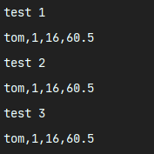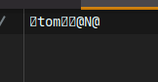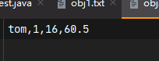
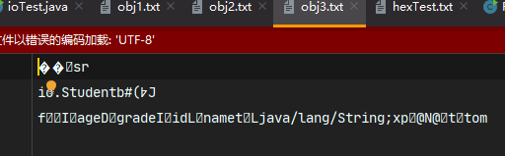

思考题：
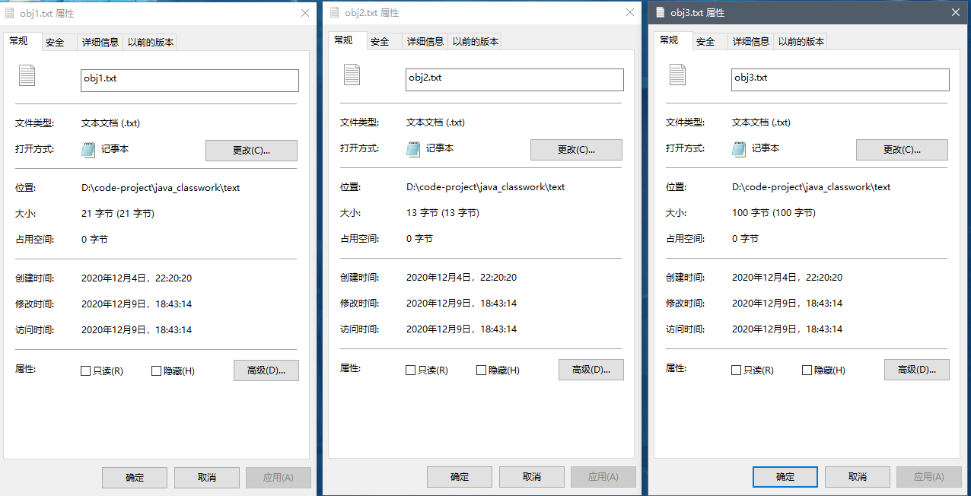

2）
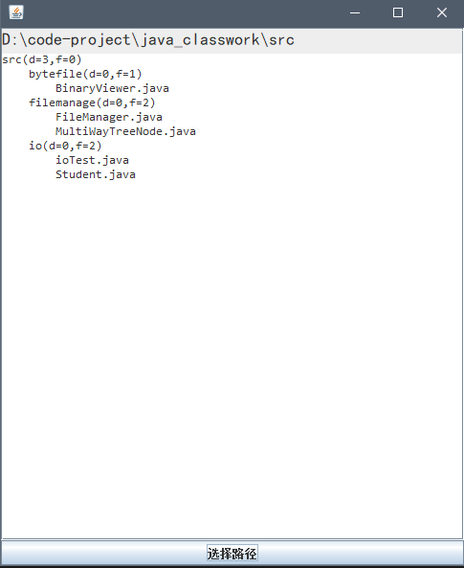

3）
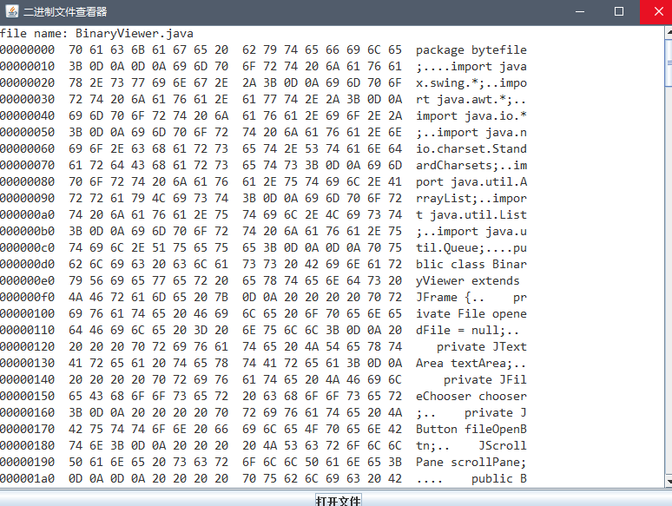

五、实验小结
1．实验中遇到的问题及解决过程
问题1：文件管理器中递归查找文件，难以添加文件夹/文件数目
解决方法：先用树将查找到的文件储存起来，同时记录文件夹/文件数目，然后再输出到窗口中
问题2：二进制文件查看器，字符流读取带中文或奇异字符的文件时会出现四位16进制数。
解决方法：先将文件以二进制为单位读取后再转换成16位。（或者使用InputStreamReader指定编码后用BufferedReader读取）
2．实验体会和收获。
Java中流有许多类型，其中InputStream/OutputStream是所有字节流的父类，Reader/Writer是所有字符流的父类。InputStreamReader是字节流转化为字符流的类，可以指定编码方式，配合BufferedReader可以实现较高效率读取字符流。BufferedInputStream/BufferedOutputStream 可以实现较高效率读取字节流。
六、附录
参考文献和相关资料。

